SLIDING ROOF / CONVERTIBLE: RETRACTABLE HARDTOP SYSTEM: MANUAL CLOSE OPERATION
1. OPEN LUGGAGE COMPARTMENT DOOR
(a) Using a screwdriver, remove the key cover.
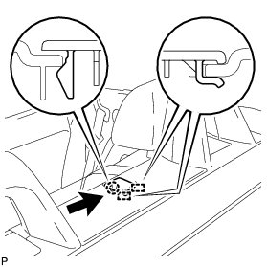
(b) Using the mechanical key, release the luggage compartment door lock.
(c) Open the luggage compartment door.
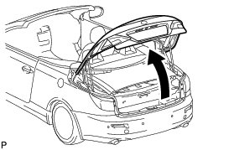
2. RELEASE FRONT OF LUGGAGE COMPARTMENT DOOR
(a) Pull the emergency release cable at each luggage compartment door hinge to release the left and right closer locks.
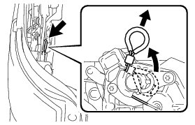
(b) Hold the luggage compartment door by the luggage compartment door hinge and move it to the position shown in the illustration.
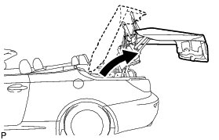
NOTICE:
* Perform this operation using 2 persons.
* Synchronize the movement of the left and right sides of the luggage compartment door when moving it.
* A large amount of force is required to open the front of the luggage compartment door. Perform the operation slowly.
* When moving the luggage compartment door, be careful not to apply force to the No. 1 and No. 2 package tray trim hinges.
3. REMOVE INNER LUGGAGE COMPARTMENT TRIM COVER LH
(a) Remove the 2 screws.
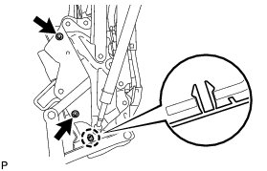
(b) Disengage the claw and remove the inner luggage compartment trim cover LH.
4. REMOVE NO. 2 SIDE TRIM BRACKET
(a) Remove the bolt and No. 2 side trim bracket.
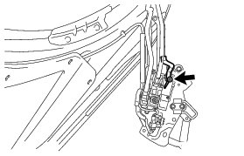
5. REMOVE NO. 2 PACKAGE TRAY TRIM HINGE
(a) Disconnect the connector.
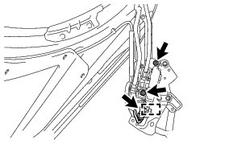
(b) Disengage the clamp.
(c) Using a "TORX" socket wrench, remove the 2 bolts and No. 2 package tray trim hinge.
6. REMOVE INNER LUGGAGE COMPARTMENT TRIM COVER RH
HINT
Use the same procedure for the RH side and LH side.
7. REMOVE QUARTER TRIM BRACKET RH
HINT
Use the same procedure for the RH side and LH side.
8. REMOVE NO. 1 PACKAGE TRAY TRIM HINGE
HINT
Use the same procedure for the RH side and LH side.
9. REMOVE PACKAGE TRAY TRIM GARNISH LH
(a) Disengage the 4 claws and clip, and remove the package tray trim garnish LH.
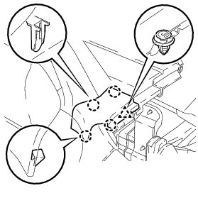
10. REMOVE PACKAGE TRAY TRIM GARNISH RH
HINT
Use the same procedure for the RH side and LH side.
11. REMOVE UNDER PACKAGE TRAY TRIM COVER
(a) Disengage the 6 clips.
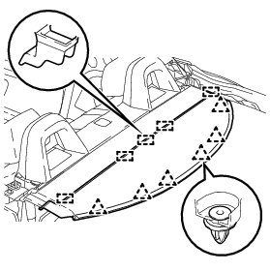
(b) Slide the under package tray trim cover toward the rear of the vehicle and disengage the 5 guides to remove the under package tray trim cover.
12. REMOVE PACKAGE TRAY TRIM COVER
(a) Disengage the 6 clips.
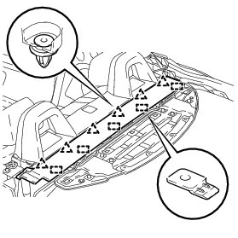
(b) Slide the package tray trim cover toward the front of the vehicle and disengage the 5 guides to remove the package tray trim cover.
13. REMOVE PACKAGE TRAY PANEL (for Front Side)
(a) Using a wrench, remove the 4 bolts and package tray panel (for front side).
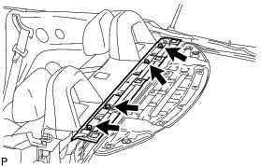
14. REMOVE PACKAGE TRAY PANEL (for Rear Side)
(a) Using a wrench, remove the 6 volts and package tray panel (for rear side).
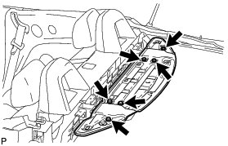
15. MOVE PACKAGE TRAY TRIM BRACKET
(a) Use a wrench to move the package tray trim bracket to the position shown in the illustration.
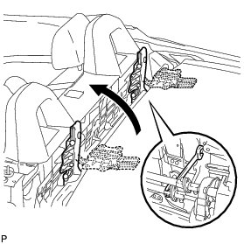
16. REMOVE SIDE BRACKET
(a) Using a 5 mm hexagon wrench, remove the 2 bolts.
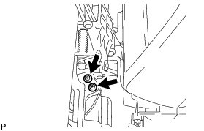
(b) Slide the side bracket toward the front of the vehicle and disconnect the side bracket from the removable roof lock.
NOTICE:
Be careful when sliding the RH side, because a limit switch is attached to it.
(c) Remove the side bracket from each side.
HINT
The RH side cannot be detached from the vehicle because a limit switch is attached to it.
17. MOVE METAL TOP ROOF
(a) Pull the roof panel out of the luggage compartment and move it to position shown in the illustration.
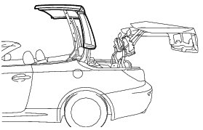
NOTICE:
* Perform this operation using 2 persons.
* A large amount of force is required to lift the roof panel. Perform the operation slowly.
(b) Using a screwdriver, disengage the claw and remove the lock cover (for front side).
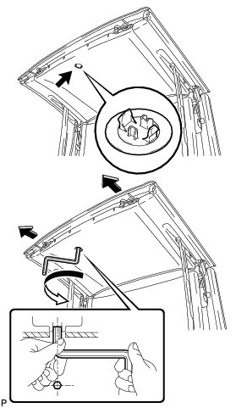
(c) Insert a 5 mm hexagon wrench into the sliding roof drive gear shaft (lock motor shaft) through the hole in the roof headlining.
(d) Looking from below, turn the wrench counterclockwise to release the locks.
NOTICE:
* Insert the hexagon wrench all the way in and turn it with both hands.
* Do not apply excessive force after the drive gear stops turning.
HINT
The locks will release when the wrench is turned approximately 360 degrees.
18. MOVE ROOF PANEL
(a) Move the roof panel to the position shown in the illustration.
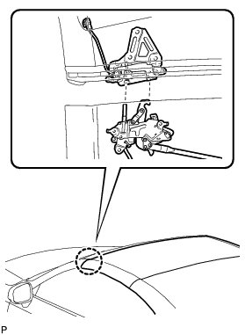
(b) Insert a 5 mm hexagon wrench into the sliding roof drive gear shaft (lock motor shaft) through the hole in the roof headlining.
(c) Looking from below, turn the wrench clockwise to engage the locks.
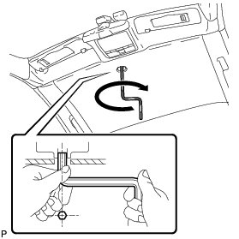
NOTICE:
* Perform this operation using 2 persons.
* A large amount of force is required to lift the roof panel. Perform the operation slowly.
HINT
The locks will engage when the wrench is turned approximately 360 degrees.
(d) Install the lock cover (for front side).
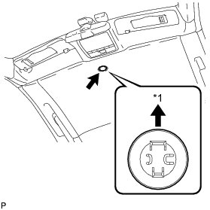
Text in Illustration

19. MOVE BACK WINDOW FRAME
(a) Pull the back window frame out of the luggage compartment and move it to the position shown in the illustration.
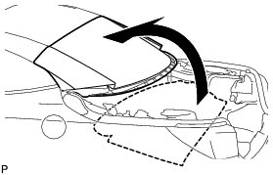
NOTICE:
* Perform this operation using 2 persons.
* A large amount of force is required to lift the back window frame. Perform the operation slowly.
(b) Using a screwdriver, disengage the claw and remove the lock cover (for rear side).
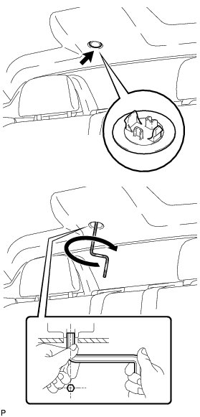
(c) Insert a 5 mm hexagon wrench into the sliding roof drive gear shaft (lock motor shaft) through the hole in the roof headlining.
(d) Looking from below, turn the wrench clockwise to engage the locks.
NOTICE:
* Insert the hexagon wrench all the way in and turn it with both hands.
* Do not apply excessive force after the drive gear stops turning.
HINT
The locks will engage when the wrench is turned approximately 360 degrees.
(e) Install the lock cover (for rear side).
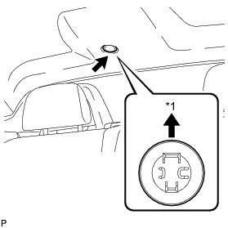
Text in Illustration
20. STOW REMOVED PARTS
(a) Stow the removed parts.
21. CLOSE LUGGAGE COMPARTMENT DOOR
(a) Hold the luggage compartment door by the luggage compartment door hinge, move it to the position shown in the illustration and lock it.
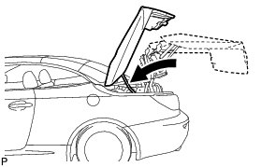
NOTICE:
* Perform this operation using 2 persons.
* Synchronize the movement of the left and right side sides of the luggage compartment door when moving it.
(b) Close the luggage compartment door.
HINT
The luggage compartment door will be half-latched because the closer motor will not operate to fully latch it.
pro multis · About Operation CHARM

