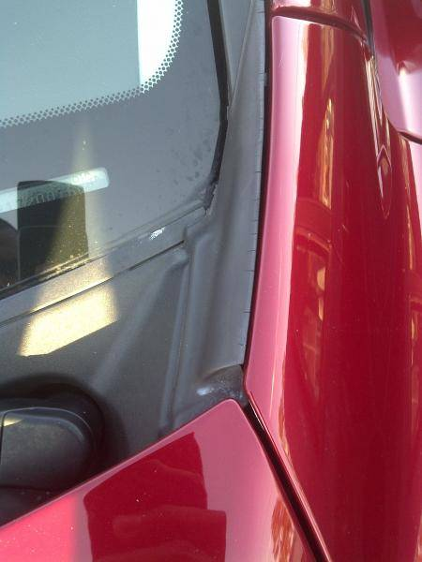
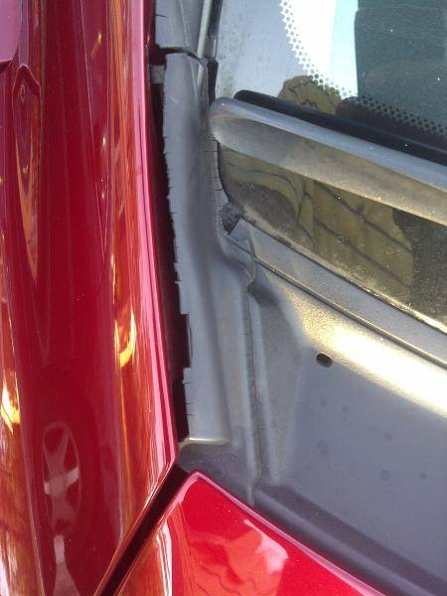

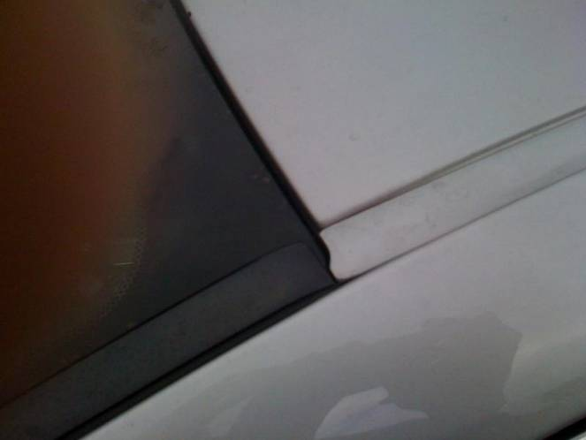
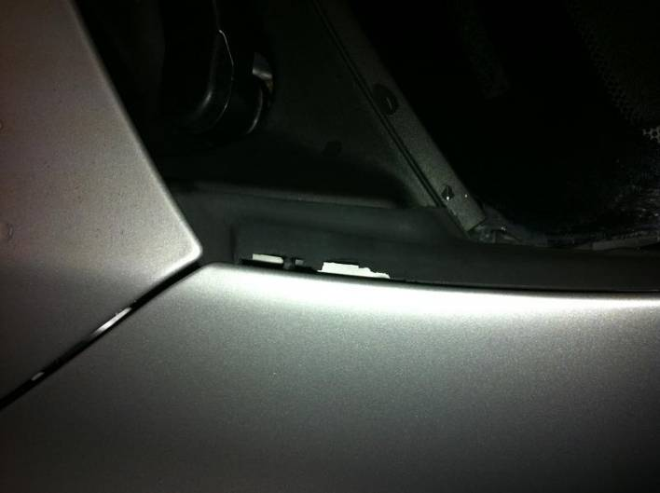
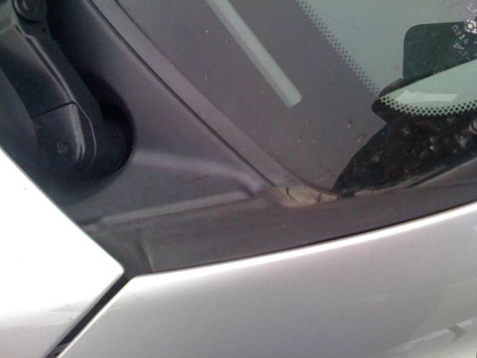
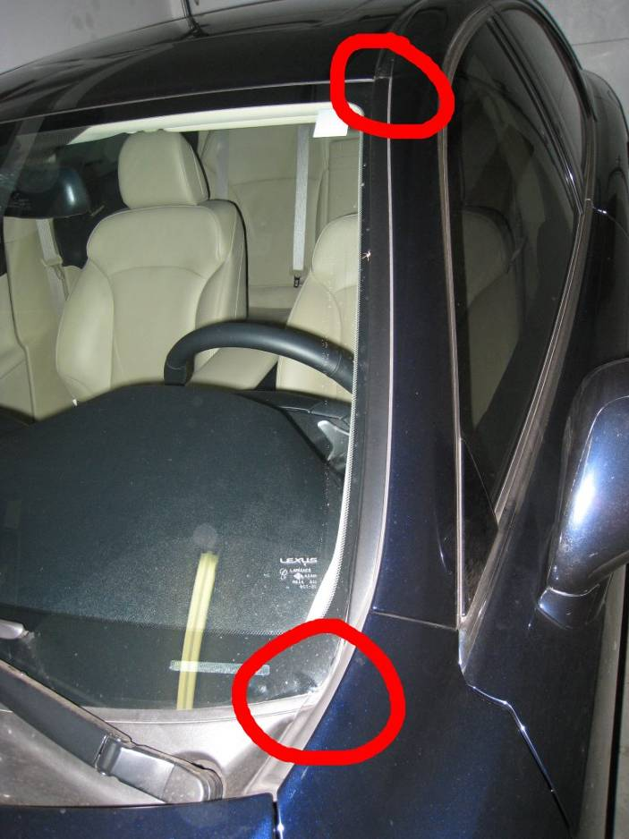
5 clips (75545-53010 $3.98ea)
Molding pieces:
RH (75551-53020 $37.13)
LH (75552-53020 $37.13)
Hook at bottom of mold pieces usually broken

http://www.clublexus.com/forums/is-second-generation/494294-windshield-molding.html
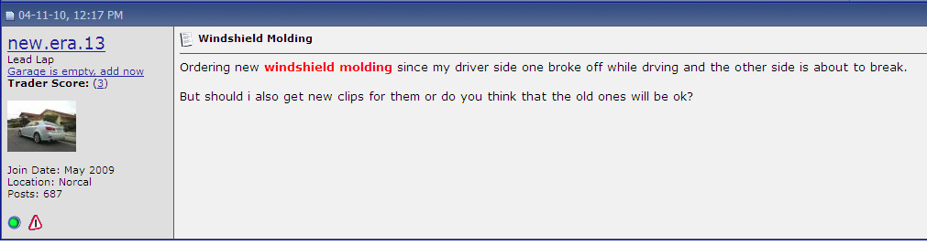
http://www.clublexus.com/forums/is-second-generation/439610-windshield-molding-problem.html
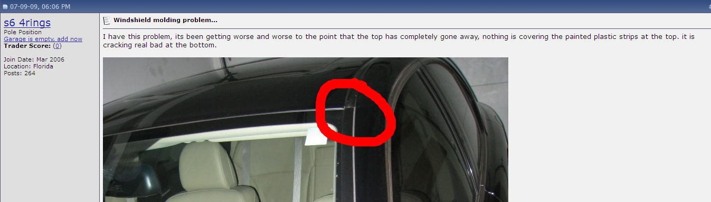
http://www.clublexus.com/forums/is-second-generation/328265-windshield-molding-cracking-and-chipping-away-anyone-else-have-this-problem-pics.html
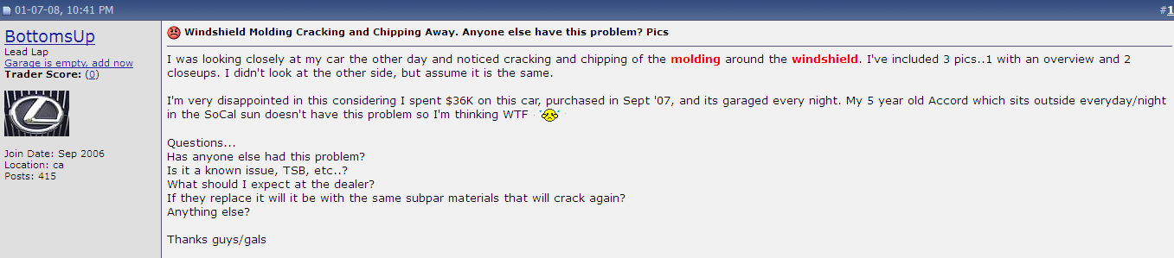
http://www.clublexus.com/forums/is-second-generation/412006-is-this-covered-under-warranty.html
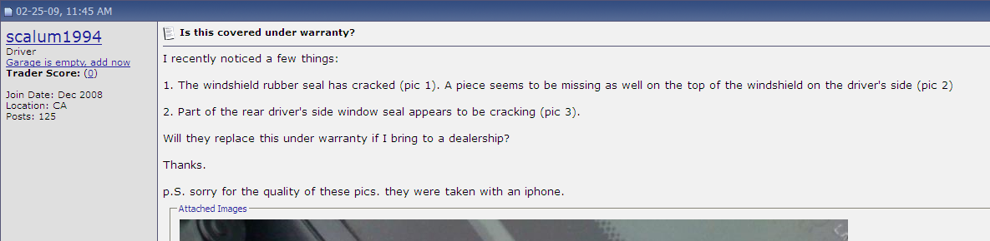
http://www.clublexus.com/forums/is-second-generation/541677-windshield-trim-chipping-under-coverage.html
