2007 Lexus RX-350 Klunk-Thump Wobble Whipping Issue
Date Line September 2011. My wife purchased a used Lexus RX350 from Kuni Lexus in Colorado Springs. Mileage at purchase was 105k. Immediately she noticed a “Klunk-Thump” noise emanating from the rear axle at crawl speed when bouncing the car at the curb into the driveway. I dismissed the noise as the muffler banging against the car carriage frame, because I was able to re-create what I thought was the noise by wiggling the muffler on its rubber mounts enough to make a thump against the under carriage rear spare tire. So I let the matter go.
Two years later, January 2013, we purchased a new set of Bridgestone “Dueler” tires for the vehicle. On the second rotation, October 2013, I had the tires balanced and rotated at the tire store – Costco. My wife immediately complained about a “wandering” effect she was feeling at high speeds, 60mph+. I took the car out and noticed it. It felt similar to how new tires wander on a fresh rain-grooved concrete freeway. There was a side-to-side slightly rocking motion felt in the whole vehicle as opposed to the steering wheel. But it would come and go – not consistent and I wasn’t able to re-create it at will. It seemed to occur with a very slight left (lane change type) turn of the steering wheel. And it was most pronounced at specific speeds such as 68 and 76 mph. Very strange. I immediately suspected the tires – something akin to radial wobble from the old days when tires conformed to the road such that rotating them caused a wobble to the vehicle. The vehicle had 142k miles at this point.
I returned the car, (within a week), to Costco where they completed a suspension inspection and checked the tires. Nothing turned up. Everything tight and within spec. But they did find two tires that were out of balance by ½ oz., on opposite sides of the car. (That tells me that Costco can’t necessarily be trusted for a good Rotate and Balance job under normal routine maintenance) Thinking the balance solved the issue I took the car out only to realize the problem was still there. Back to Costco. This time they performed a serious inspection of the suspension system and parts and came back empty handed. Everything, it seemed was tight and within spec. Alignment was suspected. I instructed them to return the tires to the pre-rotation positions and I re-tested the vehicle. Still wobbled. In fact, the wobble/whipping was so serious that the car had the potential for becoming unstable – especially in bad weather conditions.
Still suspecting the tires I took the car back to Costco, again, and they generously agreed to refund a pro-rated warranty on the tires. So I put a new set of Michelin tires on the car from Peerless Tyre. They carefully balanced the tires to zero after I explained why I was replacing the Bridgestone’s. The car continued to whip and wobble at high speed. Bummer. I began looking seriously at the suspension system. I had Brakes Plus align the vehicle and when the problem was still there I took it in to an alignment specialist – Jack’s Alignment, where Jack assured me the struts were the problem. So I bought and installed new struts. But the problem remained.
I went back to Jack’s where another suspension inspection was performed and Jack seemed to think the upper strut plates were the problem. He said there was a binding on the front struts that appeared to be related to the upper strut mounting plates that was causing the problem. (See Fig 1) Jack’s suggestion was to replace the upper strut-mounting plates.
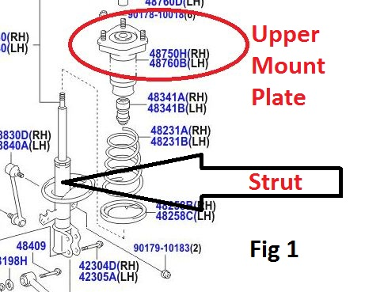
So I purchased new upper mount plates and had Brakes Plus compress the springs and install the bearings. I installed the struts again. The problem got worse. Seriously worse. Now, at high speeds, the vehicle was whipping back and forth with a serious symmetrically loose motion. (The Klunk-Thump noise was still present but everybody overlooked it, including me, thinking it was unrelated) It wasn’t the tires. It wasn’t the struts. And the suspension system parts checked out tight. So just before Thanksgiving I dropped the car off back at Kuni Lexus Dealership for diagnosis and repair. They kept the car for a month before finally locating the problem.
It turned out that Brakes Plus installed the front strut bearings upside down. This resulted in a binding of the front steering that made the vehicle steering, jerk incrementally instead of turning smoothly from side to side. Jack was right. But reversing the strut bearings didn’t correct the whipping/ wobbling problem. Regardless of smooth steering the rear of the vehicle would whip side-to-side at high speeds. The feeling while driving was akin to a force at opposite corners of the vehicle pushing down and lifting up in opposing synchronized rhythm.
Ultimately the problem rested with a worn bushing in the passenger rear axle knuckle assembly. The forward stabilizer/link arm was moving about a quarter inch, - front to back - where it should have been tight and solid. (See Fig 2) The bushing was tight but would wiggle back and forth about a quarter inch using a screw driver as a lever. The effect of the front to back play was to allow the wiggle to transfer to the tire to cause a systematic wobble about a quarter inch back and forth, side to side. Hence, the high speed side-to-side wobble was originating with a front-to-back motion at the stabilizer arm that allowed the tire to move side-to-side similar to the effect of a warped brake rotor. At high speed this back and forth motion amplified through the car carriage to cause a rocking and whipping back and forth. (The steering wheel did not wiggle or wobble during the symptoms thus indicating the problem was in the rear suspension)
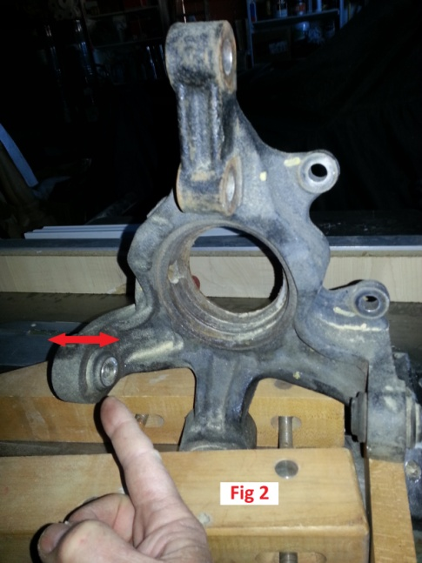
The reason the problem was so difficult to detect is the stabilizer/link rod was tested from side-to-side as the problem symptoms would suggest. It was tight under this test. Nobody thought to test the bushing front to rear as what ultimately turned out to be the problem. Fig 3, is a picture of the newly installed knuckle assembly that has the bushings built-in as an integral part of the whole assembly instead of simple individual bushings that could be independently replaced. The final repair in terms of dollars and cents amounted to approximately $1,757.23 (including the $805 to the Dealer), for what should have been a $9 part, not to mention the time and effort of several weeks and multiple experts. Way to go Toyota. My wallet thanks you. (Not)
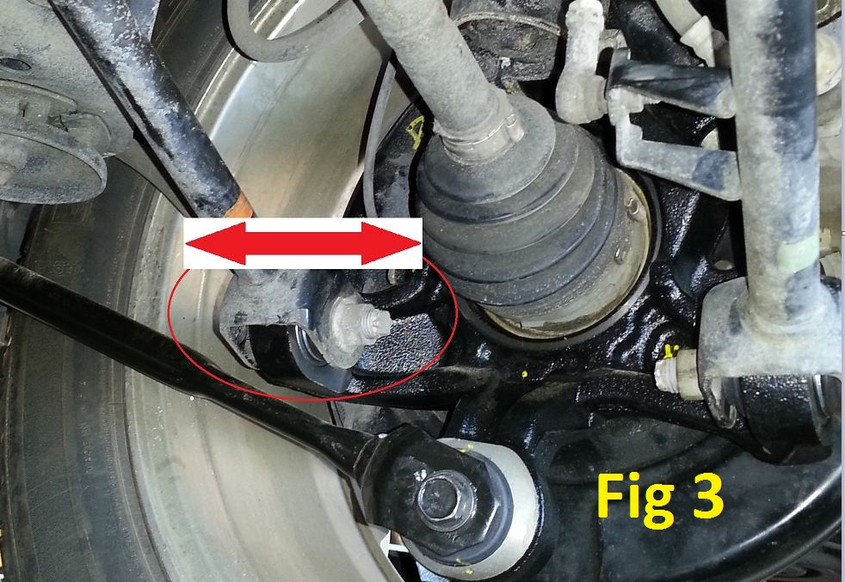
Lastly, you remember the “Klunk-Thump” noise? It strangely went away.

The ability to install the bearings upside down is an engineering defect. Any such bearing should be keyed to allow for one-way installation.

