There are no scratches on the outside of this car, but the vehicle is totaled !
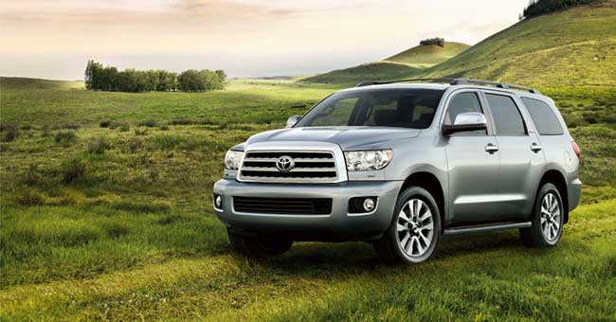
A man in Waterton Park (south of Calgary ) came out to find the inside of his 18 month old Toyota Sequoia trashed.
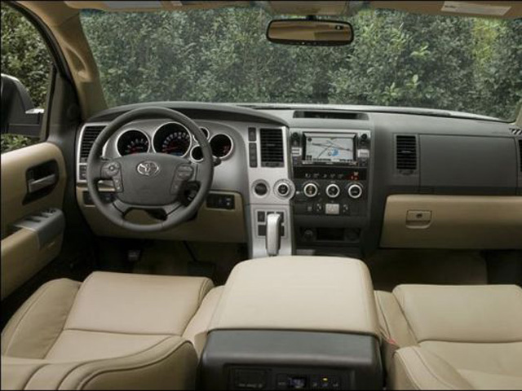
A grizzly bear had somehow got a door open.
Once inside it got trapped when the door shut behind him, probably by the wind.
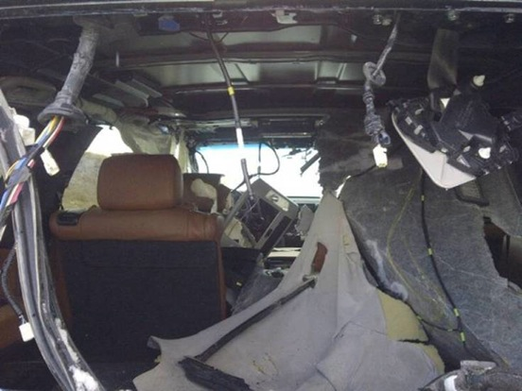
The Toyota was the Platinum edition, all the door panels were ripped off, the head-liner torn to pieces, all headrests, the leather seats, the dash shredded.
The steering column was twisted Sideways. Two of the six airbags went off, the other four the bear ripped to pieces.
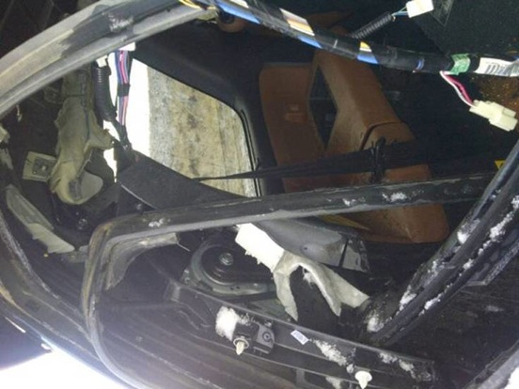
You can imagine a trapped grizzly being hit with an airbag in an enclosed space!
He must have figured he was in for the fight of his life and by the looks of this car he won the fight.
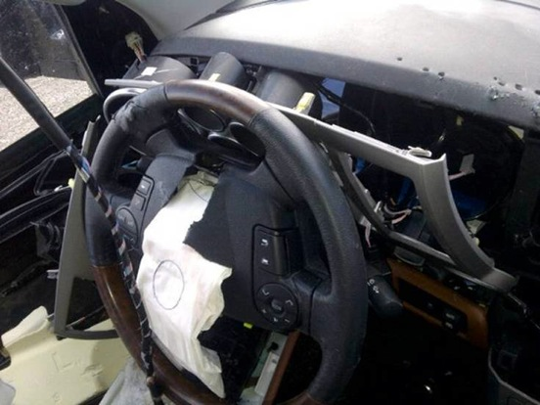
When the bear ripped off the door panels he also clawed all the wiring harnesses out.
Toyota figures every wire he pulled or clawed at resulted in alarm bells, voices or sparks.
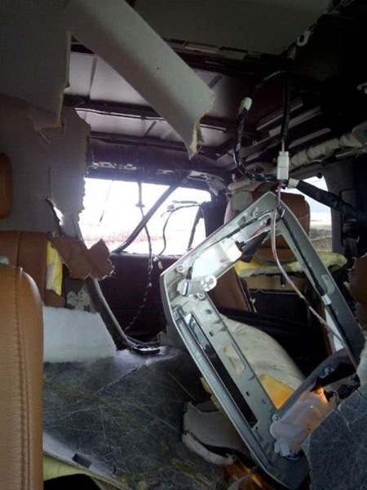
The head mechanic at Calgary Toyota doubted if they had the expertise to put this vehicle back together even if they had enough parts to do it. And to add insult to injury the bear took a big Dump in the back of the SUV . . . and then broke out the rear window.
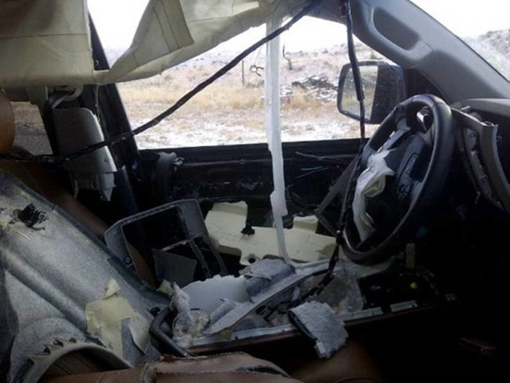
Fish and wildlife officers have inspected the damage and figure it was a 3 year old Grizzly.
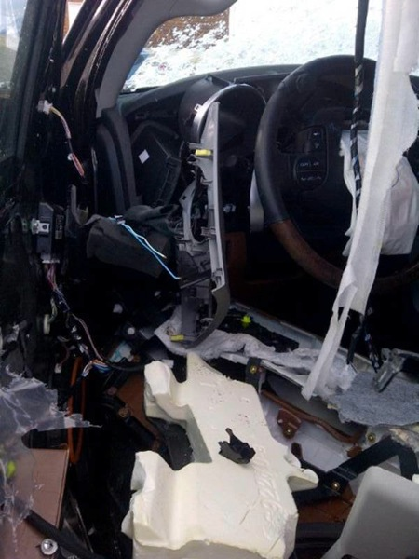
The vehicle has been written off by the insurance company.
The cost of this fully optioned vehicle new was over $70,000 and they stopped count-ing the repair costs at $60,000 plus.

