
L-SB-0073-13 September 27, 2013

Navigation System Firmware Update
Service Category Audio/Visual/Telematics

Section Navigation/Multi Info Display Market USA
Applicability

YEAR(S) | MODEL(S) | ADDITIONAL INFORMATION
2014 2014 | IS250 IS350 | Drive Type(s): 2WD, 4WDVDS(s): BF1D2, CF1D2 Drive Type(s): 2WD, 4WDVDS(s): BE1D2, CE1D2

Introduction
Some 2014 model year IS 250 and IS 350 vehicles equipped with navigation may exhibit one or more of the following conditions:
- Unit reboots at times when using various navigation/Bluetooth® operations.
- Display turns black or white, freezes, ﬂashes, or is slow to respond.
- Intermittently cannot play Pandora® or iHeartRadio, Bluetooth® Audio, DVD, or iPod.
- Bluetooth® functions are inoperative or cannot change to Phone screen.
- Erroneous navigation guidance or operation, or cannot set destinations.
- Cursor is not shown, freezes, turns black, or is slow to respond.
- Incorrect pop-up menus or pop-ups that continue to be shown.
- Blinking button(s) on various audio/Bluetooth® screens.
- Cannot use customized images or other settings.
- Cannot select applications from the HOME screen using the cursor.

• XM Satellite Radio presets not displayed. A software update is now available to address these conditions.

SPECIAL SERVICE TOOLS (SST) | PART NUMBER | QTY
USB Drive Firmware Update-DENSO* | 02009-DENSO-13B | 1

* Essential SST.
NOTE
Additional SSTs may be ordered by calling 1-800-933-8335.
Warranty Information

OP CODE | DESCRIPTION | TIME | OFP | T1 | T2
EL1313 | Update Software | 0.3 | 86804-53210 | 87 | 74

APPLICABLE WARRANTY
- This repair is covered under the Lexus Basic Warranty. This warranty is in effect for 48 monthsor 50,000 miles, whichever occurs ﬁrst, from the vehicle’s in-service date.
- Warranty application is limited to occurrence of the speciﬁed condition described in thisbulletin.

1. Conﬁrm the software version. Figure 1.
A. Cycle ignition to ACC. The LEXUS emblem will be displayed on the navigation screen.
B. Wait for the display to switch to the Caution screen, and then select Continue. The map screen will display.
C. Enter the Service Menu by cycling theheadlight switch ON/OFF 3 times while holding down the MENU button.
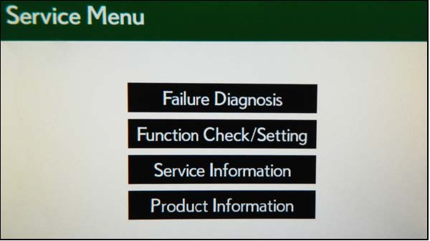
Figure 2.

Figure 3.
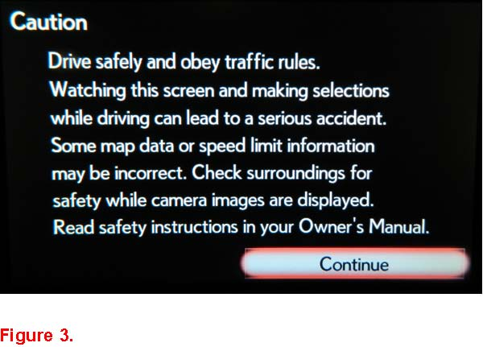

D. Select Service Information.
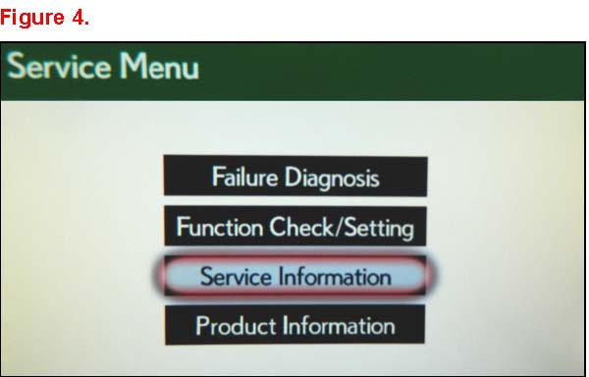
E. Select Version Information. Figure 5.
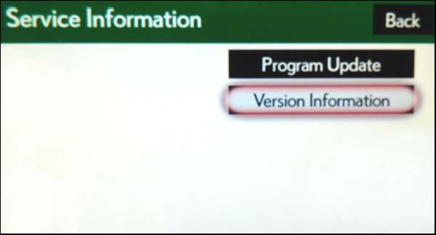
F. Select EMV-M. Figure 6.
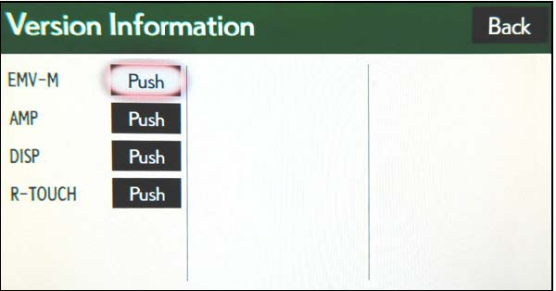
G. Conﬁrm current version is older than new version.
- If the current version is V10A8400 or greater, STOP – this bulletin does NOT apply.
- If the current version is less than V10A8400, proceed to the next step.

2. Update software version.
A. Select Back twice. Figure 7.
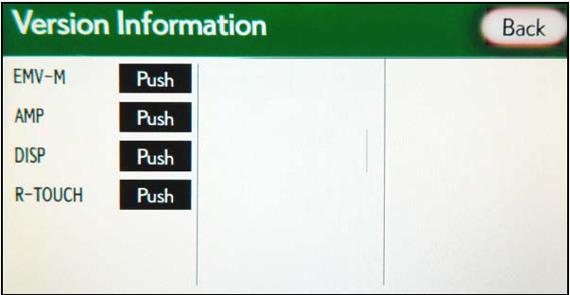
B. Select Program Update. Figure 8.
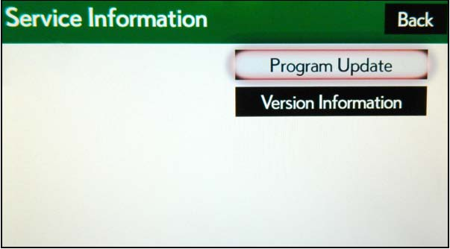
Figure 9.
C. Connect USB Drive SST to the USB port incenter console box.
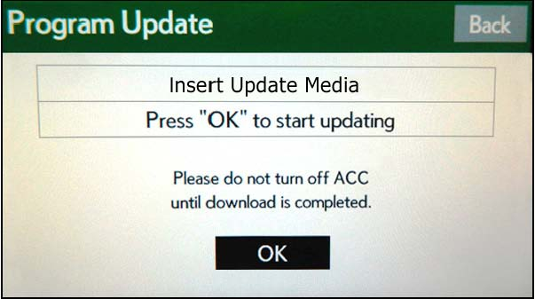
NOTICE
Do NOT attempt to close armrest. Doing somay result in damage to the USB Drive SSTor USB port.

D. Wait for the system to recognize the Figure 10. update media.
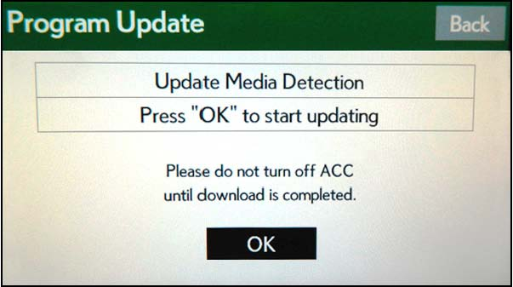
E. Select OK. Figure 11.
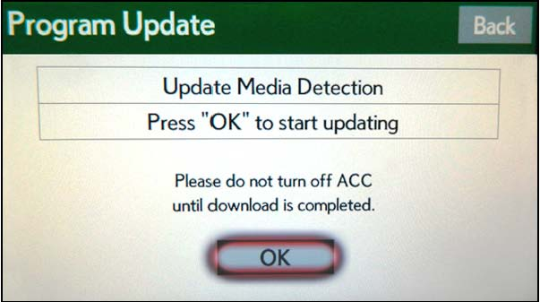
F. Wait for the upload to ﬁnish. This should takeFigure 12. about 2 – 3 minutes.
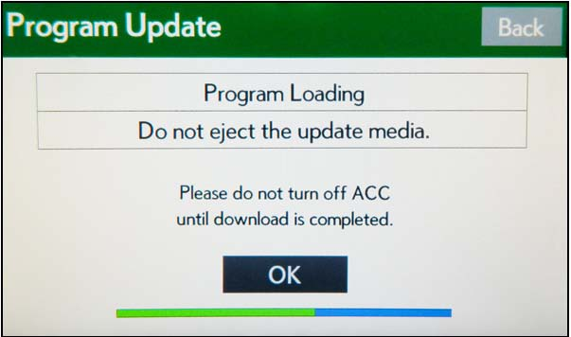

G. Once the upload ﬁnishes, the ECU Selection Figure 13. page will be displayed. Choose Select next to the new version.
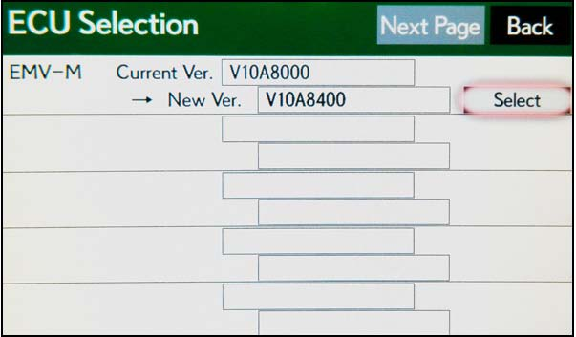
H. Select OK to conﬁrm update. Figure 14.
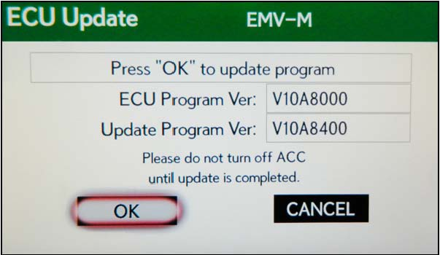

I. Wait until update is complete. This should takeFigure 15. about 3 – 5 minutes.
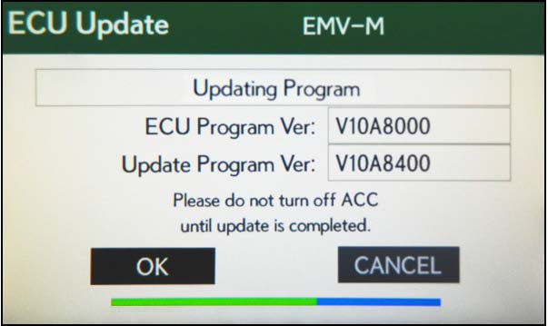
Figure 16.
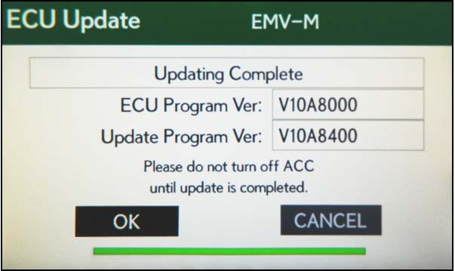
J. Select OK. Figure 17.
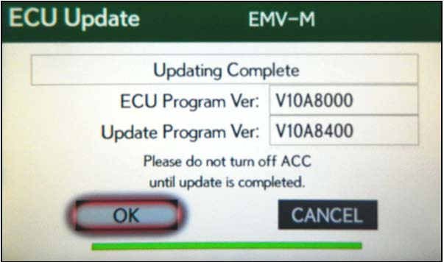

K. Cycle ignition to the OFF position and remove Figure 18. the USB Drive SST.
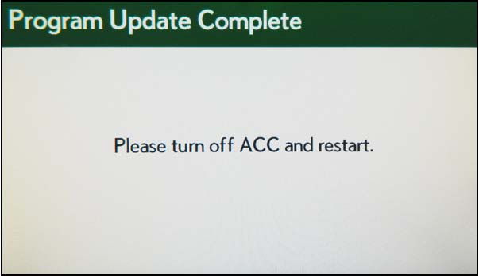
L. Cycle ignition to ACC and wait for the update Figure 19. to ﬁnish.
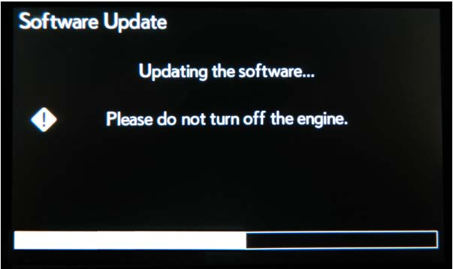
M. Following the update, the system should boot Figure 20. up as usual with the LEXUS emblem.

3. Conﬁrm the software version is updated.
A. Perform sub-steps B – F of step 1 above to navigate to the Unit Version Information screen.
Figure 21.
B. Conﬁrm Program Version is V10A8400.
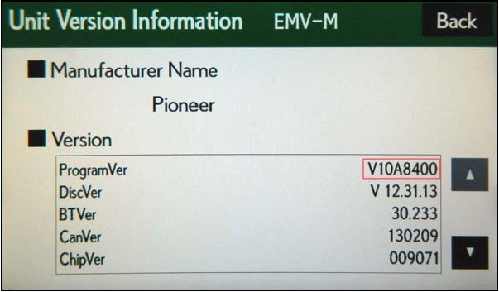
Figure 22.
C. Exit Service Mode by cycling ignition OFF orholding down the HOME button for at least 5 seconds.
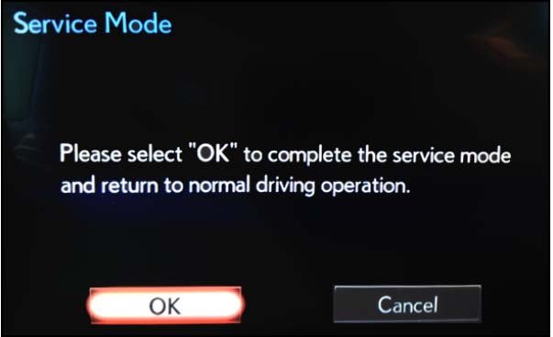
NOTE
If the screen shown appears after start-up,following the update, select OK.
䘀椀最甀爀攀..
........

