Get the credit cards dropped into central cup holder:
Because I just need to get cup holder out, it is even easier, only take 2 minutes and without any tool. (step 1-3 are not needed, step 7 also not needed – no cable or switch need to unplug). Here are detail steps:
- Remove leather sides on the center console (leather pieces on both sides). There are no screws; those just pop in. start from rear toward the front. Only 7 clips (in red) need to detach on each side(same on other side):
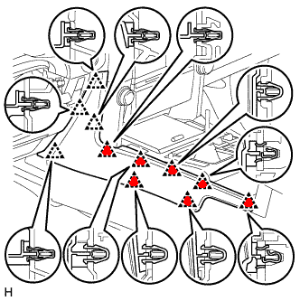
- Lift up the cup holder, upper console panel (shift lever knob) and AUX/12v power box all together (just use your fingers):

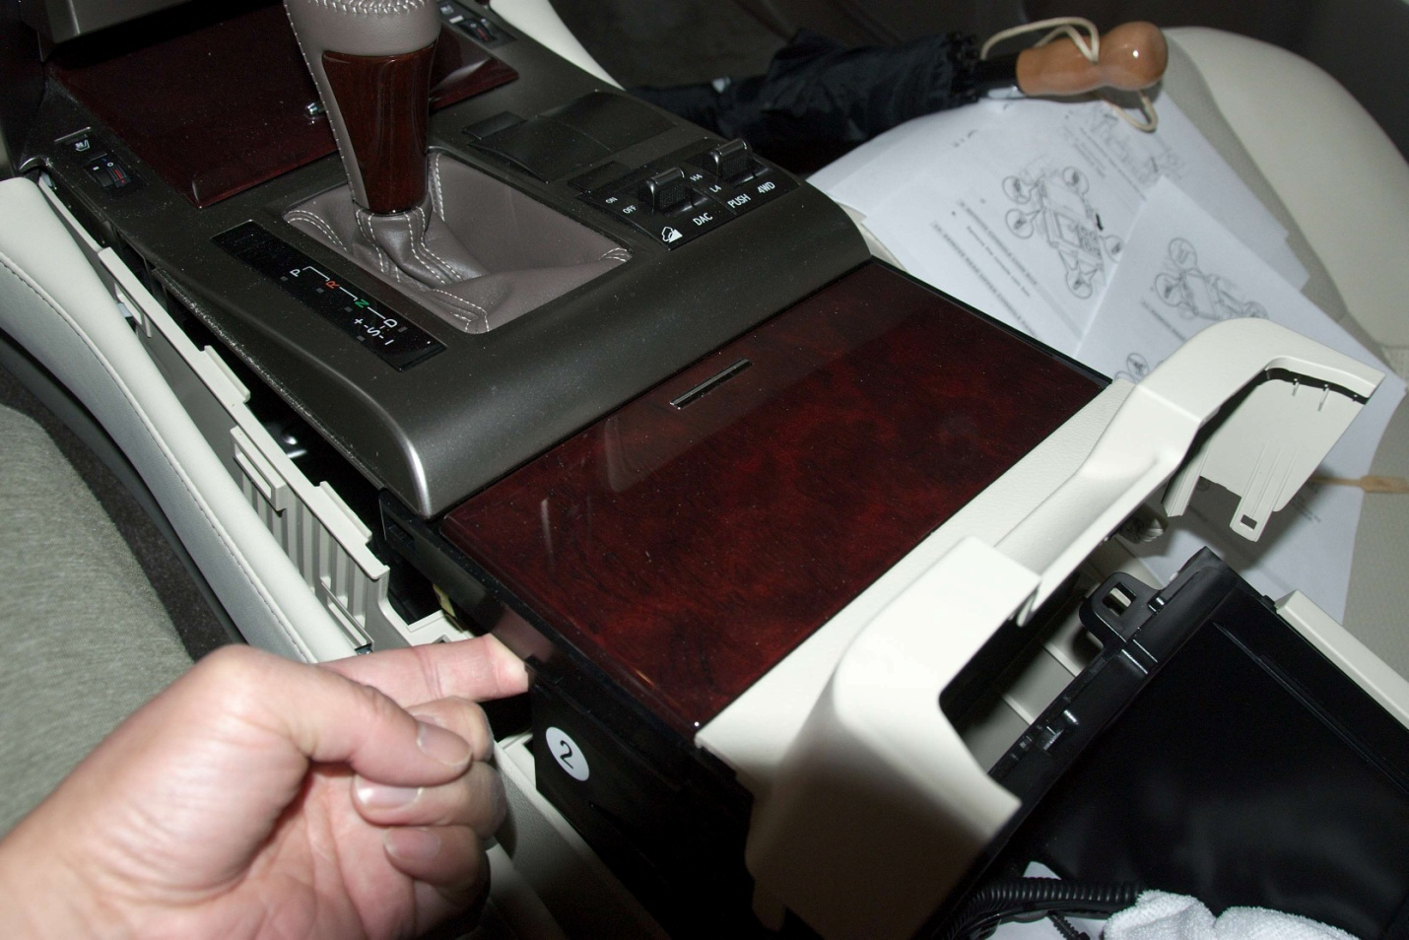
Different angles:
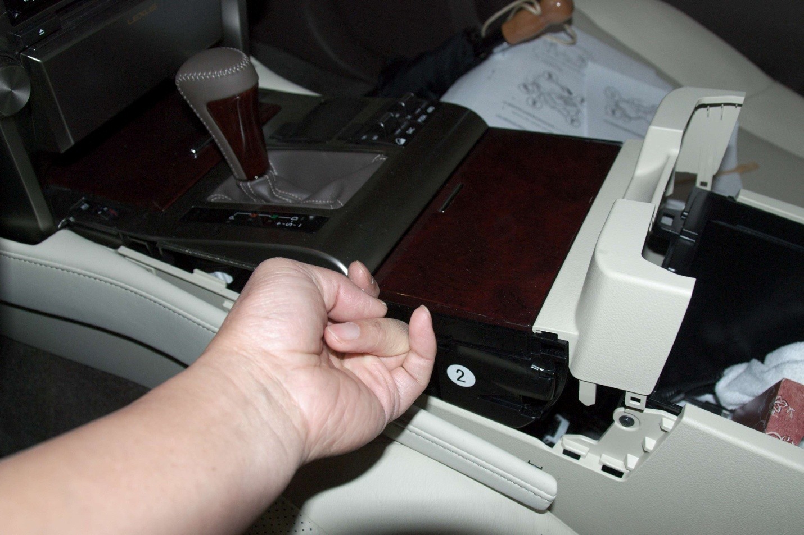

Clips positions (in RED):
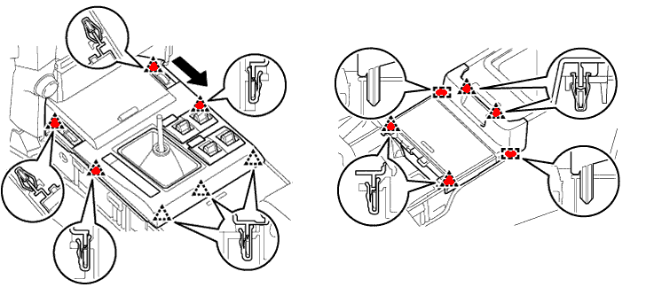
- Detach cup holder from upper console panel (3 clips in RED circles):
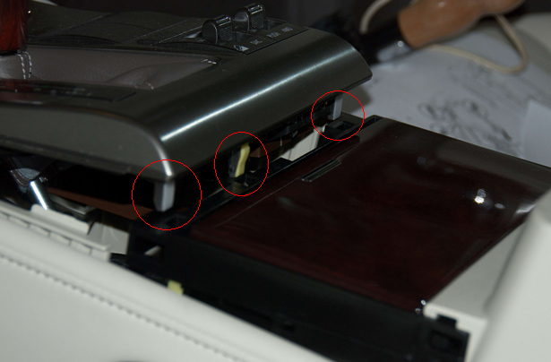

- The cup holder can be removed now:

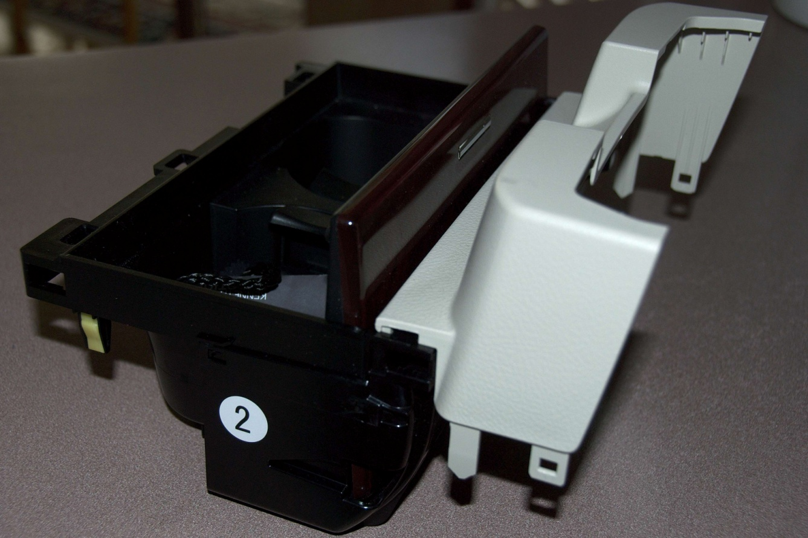
- I used a forceps to get my credit card here (red arrows):
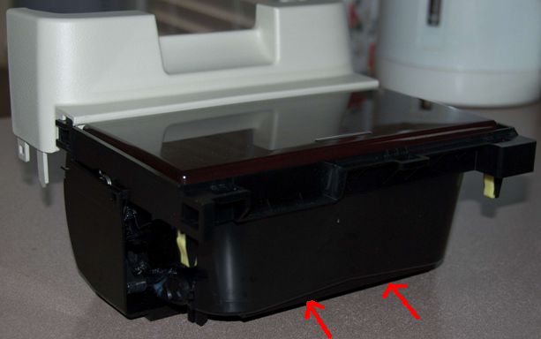
- Put back in reverse order.

